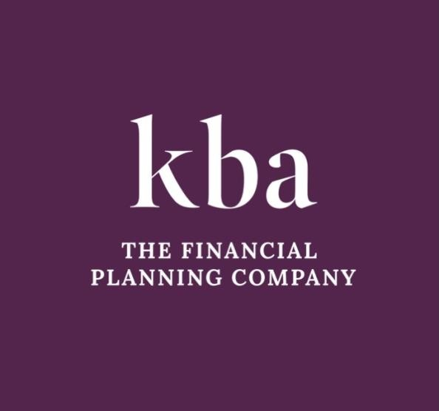

AGRICULTURAL PROPERTY RELIEF GUIDE

In association with mlplaw

www.mlplaw.co.uk

Agricultural Property Relief

INTRODUCTION

Agricultural Relief (APR) is an important tax relief available against the payment of Inheritance Tax. There are however a number of requirements to be met, and important points to consider if your property will be eligible for APR. Always take the necessary legal and financial advice when considering this issue.
Agricultural property is defined as land or pasture that is used to grow crops or rear animals, as well as buildings used in conjunction with the land.

In order to qualify for APR, the property must have been owned or occupied for agricultural purposes for a minimum of two years immediately before its transfer. If the owner does not occupy the property, such as in the case of a Let Farm Tenancy, they need to have owned it for seven years to qualify.

Key Considerations for Agricultural Property Relief

Who owns the Land?

Unlike business relief where 100% relief from inheritance tax on the market value of the land may be obtained, agricultural property relief is only available on the agricultural value of the land. In many cases, the market value is much higher, particularly where the land has development potential.

However, where the farming operation is carried out by a partnership, and the land is owned personally by the partner, only 50% business relief is available.

Check your tenancy agreement!

Another pitfall to consider is where you have a tenancy agreement that was put in place before April 1995. In this case, it is only under very limited circumstances that the full 100% relief is available and instead only 50% relief may be claimed.
Landowners with tenancy agreements in place should check their paperwork and seek advice to consider whether it would be sensible for the tenancy agreement to be updated.

Check your grazing licence

Sometimes landowners have a grazing licence in place which states that they will provide several services in relation to the land and that the person occupying the land is merely grazing. Such services may include the husbandry of the land, fertilising and seeding and keeping boundaries in good repair. It should also be seasonal. The reason for doing so, is to demonstrate that the land is still occupied by the landowner for agricultural purposes, and so that

their farmhouse may benefit from the relief. However, if this is not what is happening on the ground, HMRC will likely dismiss such a claim.

Check if your business qualifies for relief

Whether agricultural relief will apply depends on whether the land is occupied for the purposes of agriculture. For example, if you are running a livery from your land, it is unlikely to qualify for agricultural property relief. However, it may qualify for business relief depending upon the type of help offered.
It is always important therefore to seek expert advice on this issue, which can be complex, in order to avoid significant charges to Inheritance Tax.
For more information and advice on Agricultural Relief, contact KBA
- The Financial Planning Company on 01942 889883 or email contactme@kbafinancial.com or contact Doris Raggatt of MLP Law, 7 Market Street, Altrincham, Cheshire, WA14 1QE ON 0161 926 1538 and doris@mlplaw.co.uk.

This Guide contains public sector information licensed under the Open Government Licence v3.0. Source of information can be found at: www.gov.uk/guidance/agricultural-relief-on-inheritance-tax.

KBA The Financial Planning Company is a trading name of KBA FS Limited which is an appointed representative of The Openwork Partnership, a trading style of Openwork Limited which is authorised and regulated by the Financial Conduct Authority.

HM Revenue and Customs practice and the law relating to taxation are complex and subject to individual circumstances and changes which cannot be foreseen.

Approved by The Openwork Partnership on 09/10/2023.

